|  |  |
| --- | --- |
| RMIT University - YouTube  QUALITY PREDICTION FOR LEARNING RESOURCES  *Data Science Postgraduate Project (2150) Report* | **Industry Partner**  Go1 Pty. Ltd. **supervisor**  Bahar Salehi  Gaya Jayasinghe  **TEam Name**  Data Wizards  **TEam Members**  Anurag Karmarkar – S3829070  Malileh Habibi – S3814552  Pallavi Bhimte – S3758167  **Course code**  COSC2667  **year**  October 2021 |
|  |  |

**Index**

**Abstract**

**Introduction**

Nowadays, especially after the advent of Covid, face-to-face training is in many cases almost impossible. Many companies and individuals have This document is prepared as our post-graduate project. The title of the project is “Quality Prediction for Learning Resources.” The industry partner project is “Go1 Pty Ltd”. Go1 is one of the largest libraries of e-learning training providers. It is available for subscription on the existing learning platform or on its site to upskill and retrain the staff, using the best training courses [1].

**Background**

Nowadays, especially after the advent of Covid, face-to-face training in many cases is almost impossible. Several companies and individuals have turned to online education in such situations. Modern life has become even faster and exhausting for many. Given that most workplaces are at home and companies are rapidly evolving and changing roles, it is essential that your e-learning meets expectations and guarantee performance [2].

Go1 is a fully featured worldwide e-learning resource company that provides training courses and a marketplace for more than 100,000 courses. It would devote to offer the best possible learning options for improving lives using training. It teaches you the skillset to solve problems in a cost-effective manner. Moreover, it is also useful for small and medium enterprises, professionals, and start-ups who want to provide their employees with industry-grade skills. They are comitted to create and maintain a culture in which everyone can participate and make a positive effect. Go1 would help you to grow individually, as a team and as an organization. Its culture helps to deliver the best possible learning experience for the clients and all learners around the world.

Go1, gives you a variety of courses that can help you meet multiple industry standards. In addition, their employee tracking tools that allow you to track your employees' progress through their scheduled periods. This solution also provides you with benchmarks to know how the courses are and how the platform is performing. [3]

**Aims and Objectives**

Initially the project aimed at predicting the quality of the learning resources by considering the number of clicks on the learning resource, consumption (average time spent on the learning resource), and conversions as the target. However, that approach was discarded by the industry mentors as they thought that user engagement would be a better metric for predicting the quality of the learning resource. Hence, engagement became the new target variable. Thus, the aims of the project were modified as follows:

1. To investigate the features that help in predicting the quality of the learning resource using various data modeling techniques.
2. To predict the engagement using the numeric learning resource features.
3. To check if the title column can be used to predict the engagement

Bonus Tasks-

i. To check the optimal visual quality in the data

ii. Find the words in title column that bring more user engagement

**The Datasets**

In this project, seven data sets are considered for analysis and all of them have been provided by the industry partner, Go1. We will discuss these data sets in more detail as follows:

There is a total of five datasets provided by Go1. These are as follows:

**Learning Resource Features** – This dataset consists of 9 features including lo_id, type, producer_id, title, description length, topics, visual_quality, estimated_duration, and producer_reputation (figure1). It has all the information about 43175 learning objects. The visual quality ranges are {2,3,4,5} and the higher the value means the higher the visual quality. The producer reputation varies between -1 and 3. The higher value indicates a better reputation, and the negative value means the producer's reputation is not good at all.

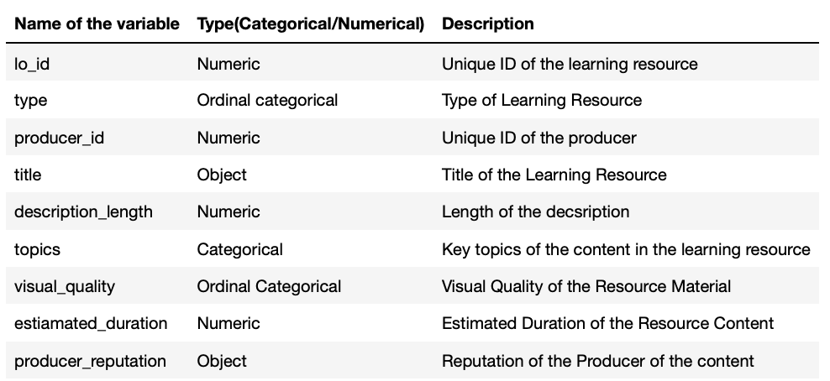

Figure 1: Description about columns in learning_resource_features dataset

**User Behavior Data**

**Clicks** – It gives the number of clicks related to each lo_id and consists of two variables lo_id and counts.

**Consumption** - This dataset includes two columns, lo_id and avg_time_spent_in_seconds which indicates the average time has been spent on each learning resource.

**Conversion** - The table has three variables: lo_id, conversion_type that show the type of each conversion and count columns indicates the number of each conversion of a learning resource for each type.

**Feedback** – the feedback dataset contains 9 columns and 2793 rows. All columns are numeric with no missing value. This table helps to recognize the more successful learning resources according to the customers feedbacks. The columns usercnt shows the number of customers who left feedback on a learning resource. The other columns including too_easy, suitable, too_hard, relevant, irrelevant, overall_like and overall_dislike show user’s ideas about the special learning objective.

**Enrolment_count** – It shows the number of customers who enrolled in a learning object and consists of 2 variables, lo_id and total_enrols**.**

**Completion_count** – the objective of this dataset is to show the number of customers who has completed the learning object. It also has two columns lo_id and total_completion.

**Approach/Methodology**

**Data exploration *- Week3***

Firstly, the exploratory Analysis on all five Datasets including Clicks, Consumption, Conversion, Feedback, and learning_resource_features has been performed.

Considering the Learning Resources Dataset, this dataset aims to understand the features of the various learning resources. It has a total of 43175 observations with 10 attributes There are no missing values in lo_id, type, producer_id, title, description_length, topics, and visual quality while estiamated_duration has 4 missing values following by 127 missing values (None) in the producer_reputation column. According to the dataset, as figure1 shows, most of the **learning resources** are in the form of videos although, in most of the samples, the visual quality is as poor as equal to 2. On the other hand, integration is the least present type among the learning resources. The producer reputation for most of the learning resources is average (figure2).

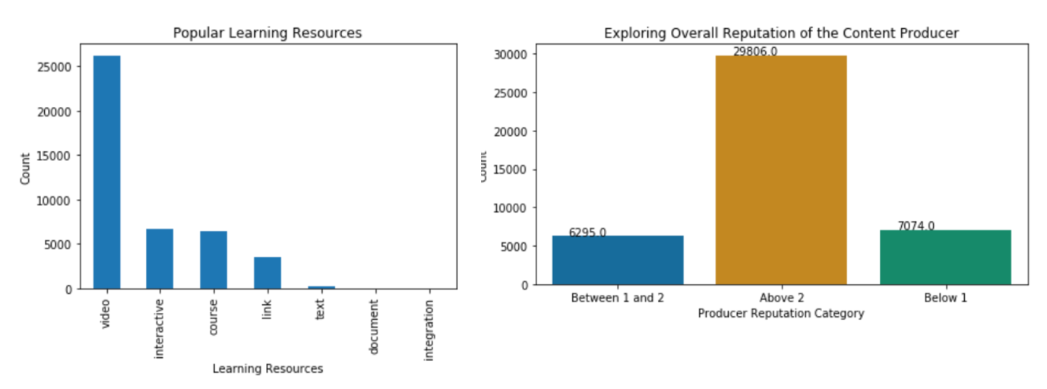

Figure 2: Popular Learning Resources & Producer Reputation Graphs

Findings from the **Clicks Dataset** are as follows:

The dataset consists of the information about the number of clicks on a learning objective with just one missing value for lo_id column. Both columns are numeric. The top 10 learning objectives are mostly business skills, leadership, emotional intelligence, and programming skills. The visual quality of the top 10 learning objectives is between 3 to 5. The number of clicks on a learning objective is directly proportional to the number of likes on the learning objective

Analysing the **conversions Dataset** which is one of the tables related to user behavior indicates the learning objective conversion. Most of the observations have “enroll” as a conversion type while the type buy has the least record in the dataset. In addition, most of the top 10 learning objectives in which the users have enrolled are of topics related to business skills and safety and compliance.

From the **Consumption Dataset** which consists of the information of the time spent on the learning objective by the users, most time is spent on the learning objectives with the longest duration and the top 10 courses with the longest consumption time are under business skills.

Looking at the **Feedback Dataset**, it isincluding 9 Columns and 2793 samples where all the columns are numeric and there is no missing data. The easiest learning object according to the users’ feedback is Work Health and Safety (Australia) while our finding also shows this learning object as the most relevant learning resource with the most like. On the contrary, relying on our analysis, the hardest and the least popular one is “Risk management overview”. We could also find “Manual tasks” as the most irrelevant learning object.

**Correlation Analysis - *Week4***

After observing the datasets, it has been decided to investigate if there is any correlation between the clicks, conversions, and consumptions with “producer_reputation” from the learning_resource_features dataset. We apply t-test hypothesis to determine if the means of two variables is similar or it is different from each other. Performing t-test hypothesis for Clicks and Producer Reputation, the P-value is much smaller than 0.05 as a result, the null hypothesis has been rejected so the true difference in means is not equal to 0. The similar results have been reached for “Consumption with Producer Reputation” and “Conversions and Producer Reputation”.

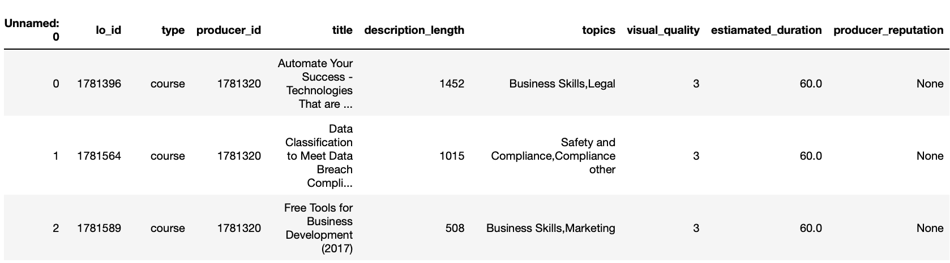

Figure 3: First few entries from the learning_resource_features dataset

Next step is merging all the datasets and removing the missing values (figure3). Creating histogram of visual quality shows (figure 5) most of the learning resources have a low quality and the boxplot of the visual quality and producer reputation (figure6) demonstrates a negative correlation between these two variables.

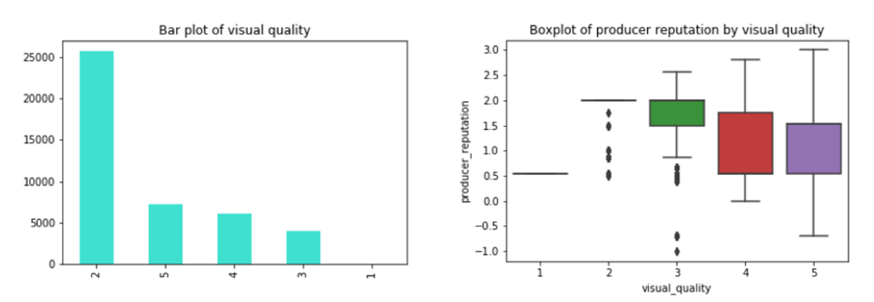

Figure 4: Plot 1: Category distribution for Visual Quality, Plot 2: Producer Reputation vs Visual Quality

With the help of Heatmap for all the variables (figure 6), there is a slightly negative correlation between the visual quality and producer reputation. Also, there is a small positive correlation between the producer reputation and the learning object id.

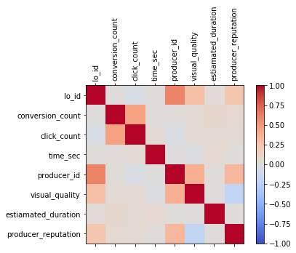

Figure 5: Heatmap for combined data (clicks, conversion, consumption & learning_resource_features)

Finally, Pearson’s correlation coefficient (figure 7) also supports the given results.

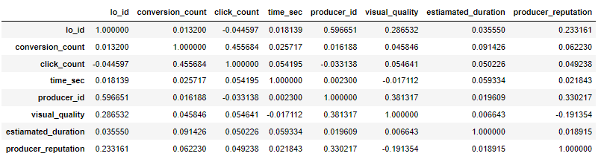

Figure 6: Pearson's Correlation Coefficient Result

Week 5 to 8 (Anurag)-

Hypothesis testing is a statistical strategy for making statistical conclusions based on data from experiments. It's essentially a guess about the population parameter that we make. In statistics, it is a necessary procedure. A hypothesis test compares two mutually exclusive statements about a population to see which one is supported best by the sample data. A hypothesis test is used to determine whether a result is statistically significant.

We have performed hypothesis testing on the following pairs of features to check if the relationship between them is statistically significant. The statistical significance of the following pairs is being tested:

1. Visual Quality and Producer Reputation
2. Completion Count and Enrolment Count
3. Type and Engagement ($\frac{Completion Count}{Enrolment Count}$)
4. Estimated Duration and Engagement ( $\frac{Completion Count}{Enrolment Count}$)

**Hypothesis Testing between Visual Quality and Producer Reputation**

The visual quality and producer reputation, both are numeric columns. The visual quality ranges from 1 to 5. The producer reputation ranges from 0 to 3. Visual quality has discrete values of 1, 2, 3, 4 and 5. Producer reputation on the other hand, has continuous values which range from 0 to 3. The producer reputation also had some negative values, which after consultation of our industry partners, were removed. The reason for the removal of rows containing negative values for producer reputation was that they were very few in number i.e., 68 out of 43175 records.

The hypotheses were as follows:

$$H_{0}:The difference between means is equal to 0$$

$$H_{A}:The difference between means is not equal to 0$$

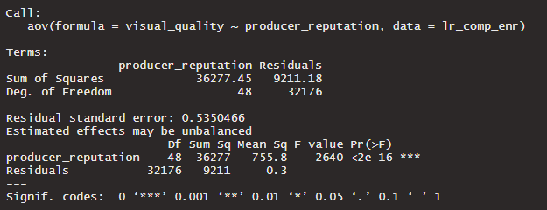

Figure 7: ANOVA Results for Visual Quality and Producer Reputation

We used the paired t-test for checking the hypothesis. The t-test resulted in a p-value < 0.05. We reject the null-hypothesis, and it can be inferred that the difference between the means is zero as well as the result is statistically significant. The hypotheses were also visualised by using a decision tree. The tree is in the following figure.

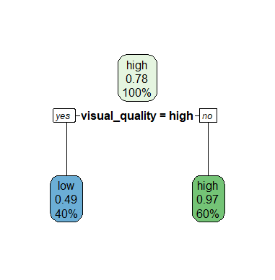

Figure 8: Decision Tree for Visual Quality

**Hypothesis testing between Completion Count and Enrolment Count**

Completion and enrolment datasets were provided to us by the industry partners to check whether these datasets or its ratio could be used as target variables to predict the quality of the learning resource / learning object. The completion count is the count of the total number of users who completed a course (learning object). The enrolment count is the number of users who have enrolled in the course. The completion and enrolment counts were found to have a positive linear relationship. The evidence of this relationship can be seen in the figure below.

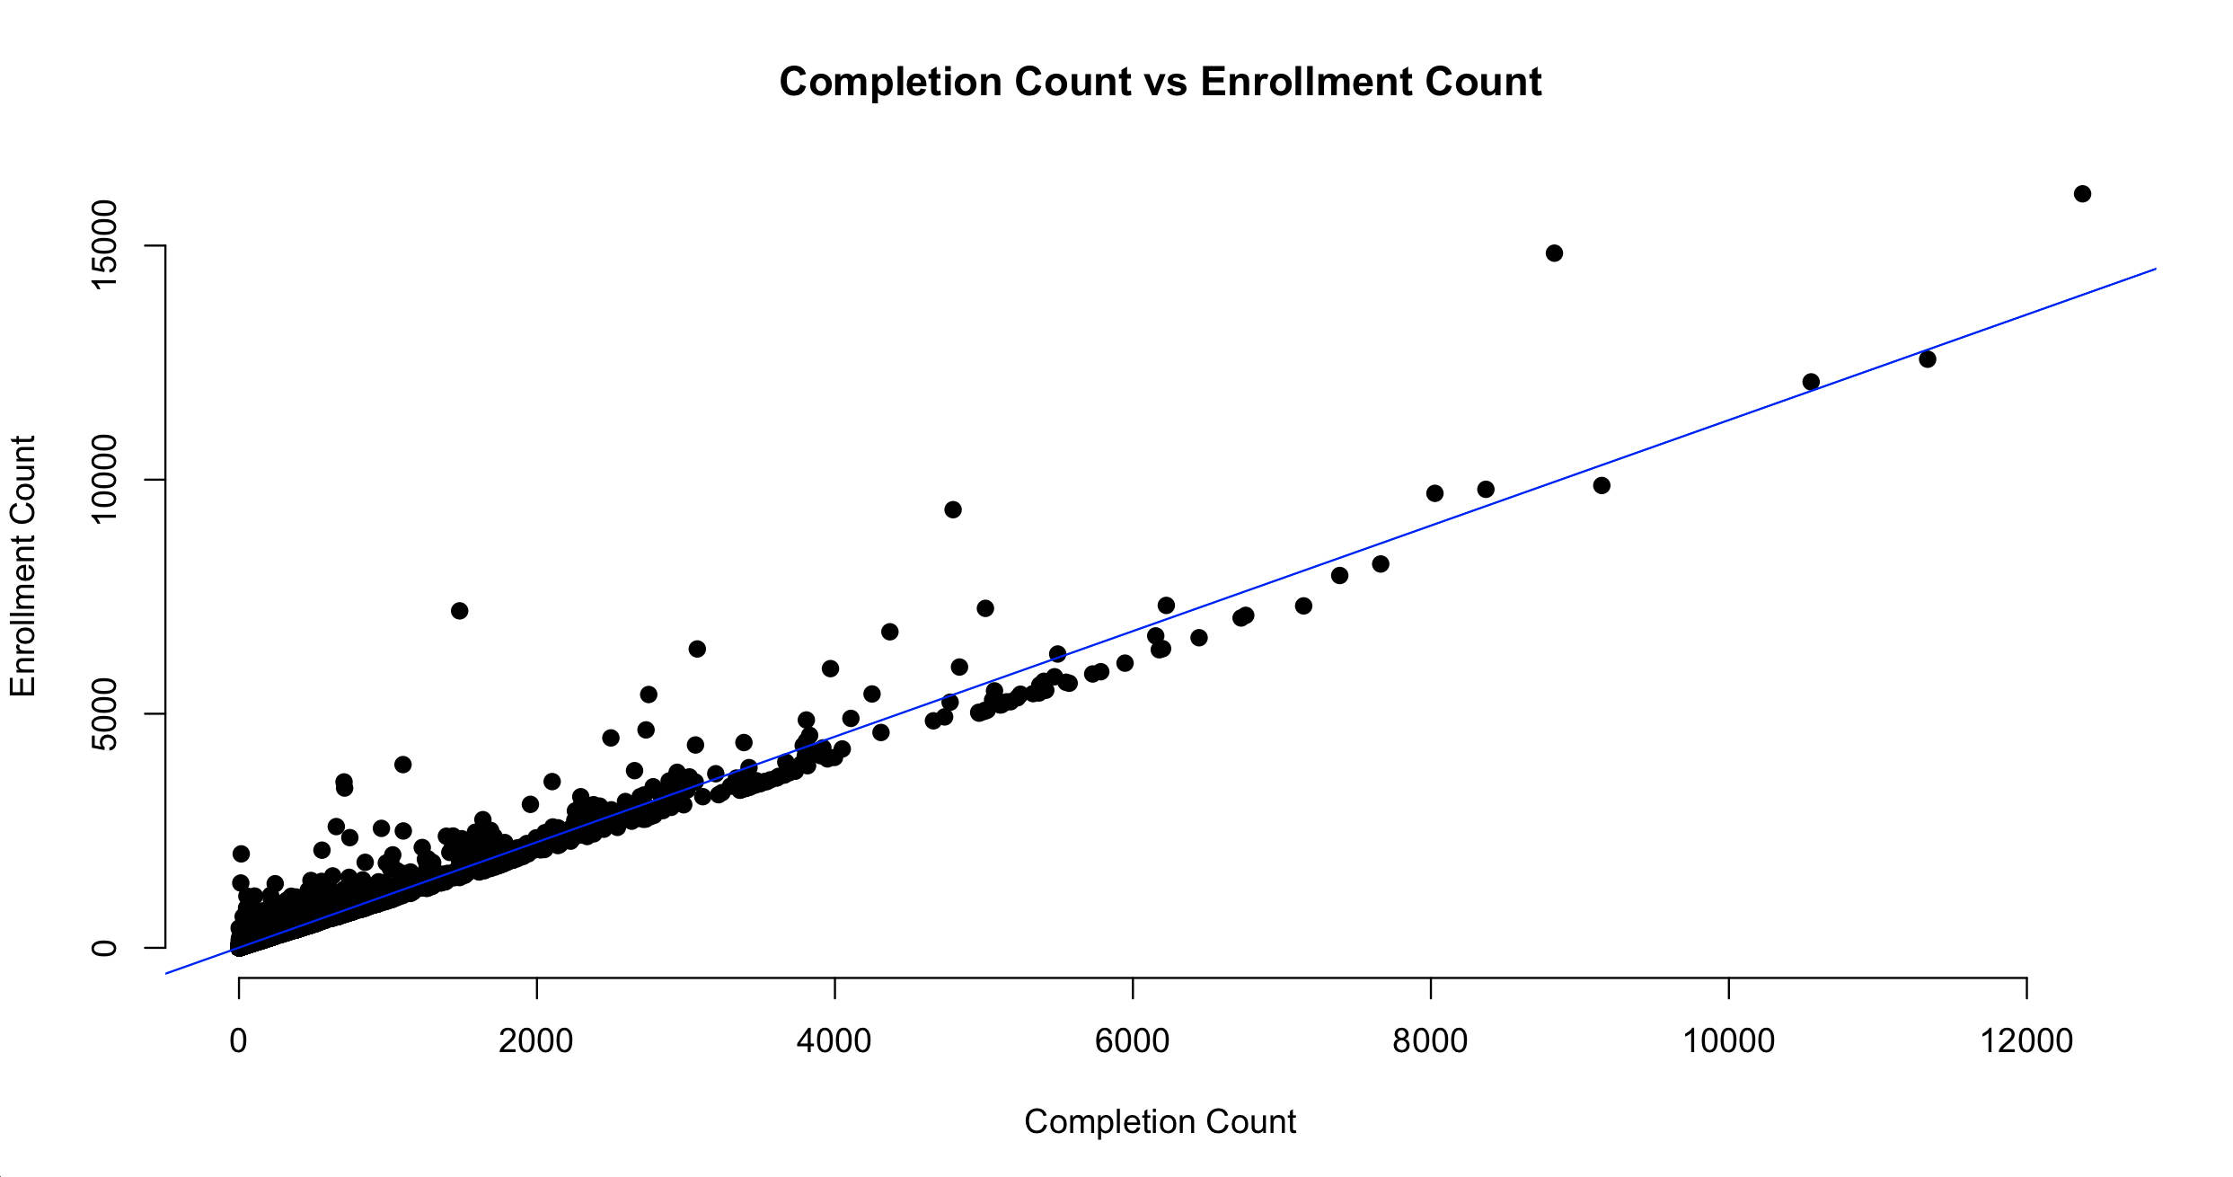

Figure 8: Linear relationship between Completion count and Enrolment count

The hypotheses were as follows:

$$H_{0}:The difference between means is equal to 0$$

$$H_{A}:The difference between means is not equal to 0$$

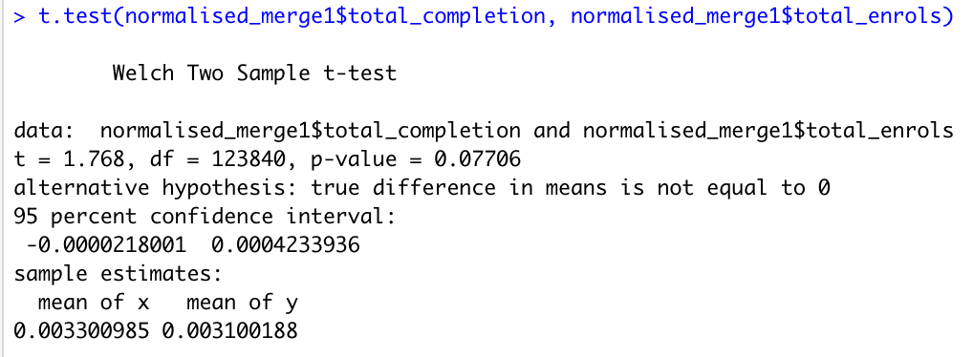

Figure 9: Welsch Two Sample t-test results for correlation between completion & enrolment counts

We have used the Welch Two Sample t-test for checking the hypothesis. The t test resulted in a p-value < 0.05. We can infer from this that the null hypothesis cannot be rejected and the difference between the means is zero and the result is statistically significant. There is also a strong correlation between the completion and enrolment counts.

**Hypothesis testing between Type and Engagement**

The engagement variable refers to the ratio of completion count and enrolment count. This ratio was expressed as $\frac{Completion Count}{Enrolment Count}$. The engagement variable became our target variable as it indicates the total proportion of the enrolled users who completed the course. Thus, resulting in a metric to study the engagement of the course in question. The type variable is a categorical variable. It consists of categories, course, document, integration, interactive, link, text, and video. We have used the one-way ANOVA test to test the hypothesis between type and engagement as one of the variables is categorical. The hypothesis between the type and engagement was expressed as follows:

$$H_{0}:The difference between means is equal to 0$$

$$H_{A}:The difference between means is not equal to 0$$

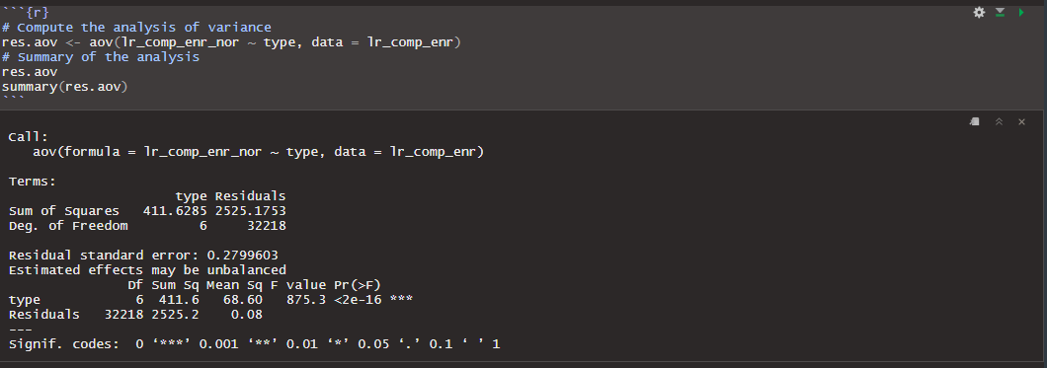

Figure 10: ANOVA (one-way) Test Results

The ANOVA test between the variables type and engagement yielded a p-value <0.05, which meant that the difference between the means is not zero. The relationship between the two variables is statistically significant.

**Hypothesis testing between estimated duration and engagement**

The estimated duration of the learning object is a numeric column. The estimated duration is expressed in seconds. The engagement column is also numeric as it is a ratio. Hence, we have used the t-test for testing the hypothesis. The hypothesis is as follows:

$$H_{0}:The difference between means is equal to 0$$

$$H_{A}:The difference between means is not equal to 0$$

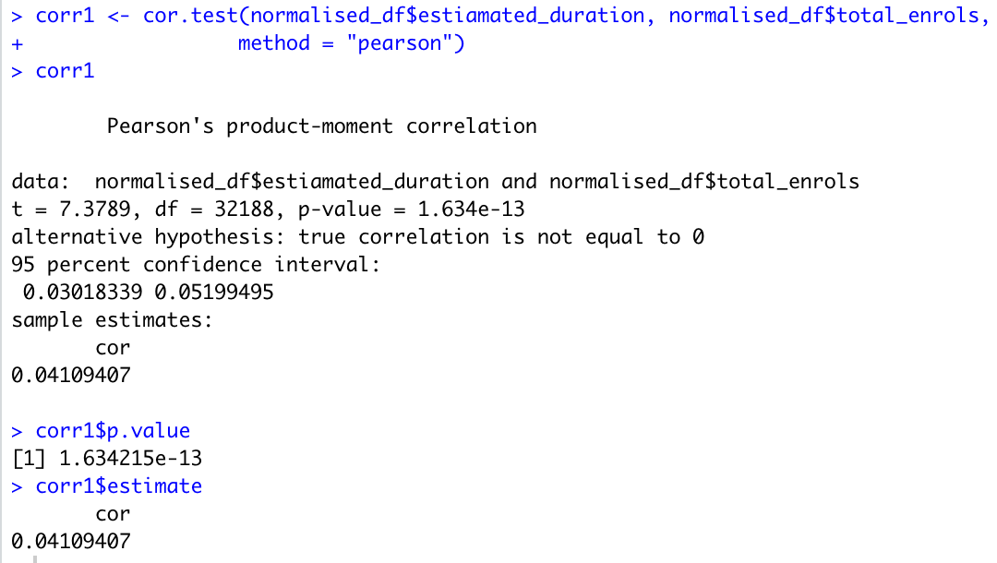

Figure 11: Pearson Correlation t-test Results for estimated duration & engagement

The hypothesis tests gave p-values less than the 0.05. Hence, we reject the null hypothesis and concluded that the difference between the means is not equal to zero and the result is statistically significant. There was an observed correlation value of 0.41 between total enrols and estimated duration.

The hypothesis tests prove that the various features in the dataset are statistically significant and have some correlation with each other. We have further conducted the Principal Component Analysis on the data.

**Principal Component Analysis**

Principal Component Analysis, or PCA, is a dimensionality-reduction approach for reducing the dimensionality of large data sets by transforming a large collection of variables into a smaller one that retains most of the information in the large set.

Naturally, reducing the number of variables in a data set reduces accuracy; nevertheless, the answer to dimensionality reduction is to exchange some accuracy for simplicity. Smaller datasets are easier to process and analyse for machine learning algorithms. In short, the goal of PCA is to reduce the number of variables.

Week 9(Pallavi)-

As the PCA performed before gave us unsure results, this time after knowing the correct approach, we realised that while merging the dataset, many outliers from the numerical columns itself got removed except for the estimated duration. Therefore, outliers had to be removed only from the estimated duration column and removal of outliers was verified by plotting a boxplot as shown below.

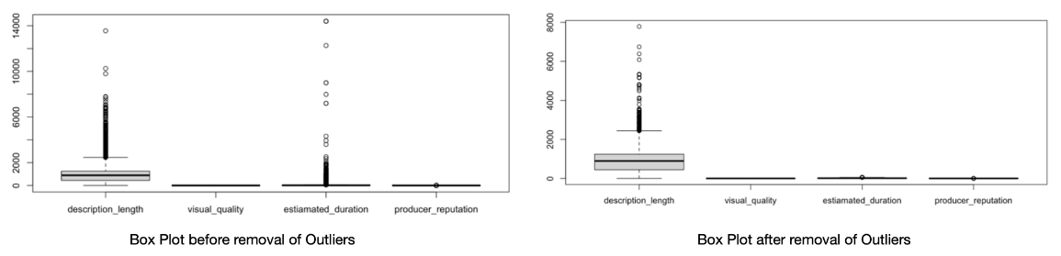

Figure 12: Boxplots for before and after the removal of outliers from estimated duration

Since the data was thoroughly pre-processed, PCA was performed that resulted in around 84.5% proportion of variance stored in the first component and approximately 10.7% of the variance stored in the second principal component. Remaining two components consisted of 5.5% of variance. To ensure this, a scree plot visualisation was plotted and then, the rotation value for each column vs individual principal components was checked.

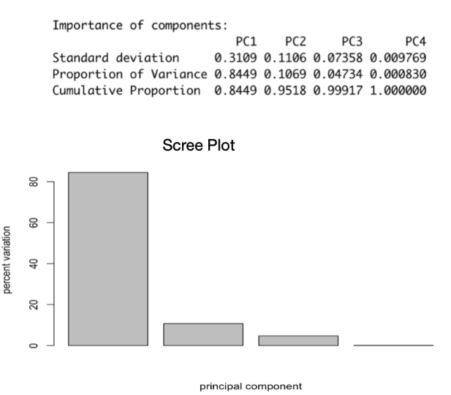

Figure 13: Scree Plot & Distributed Proportion of Variance among the principal components

The visual representation of rotation was performed by plotting a biplot that showed us the visual quality has the most rotation (-0.94) compared to other variables as shown below:

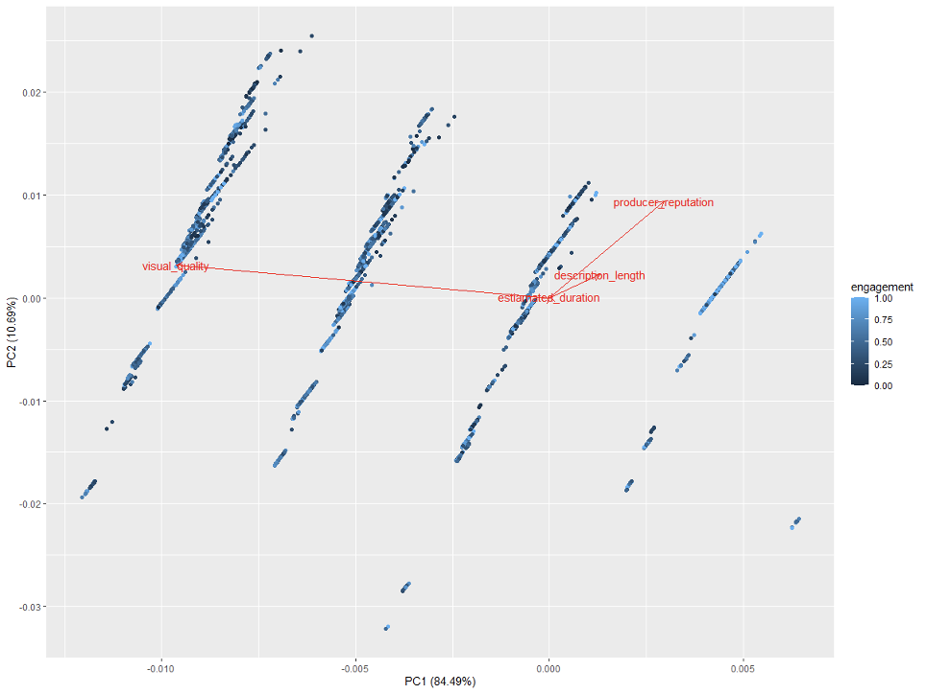

Figure 14: Rotation for different variables

With most of the variance being covered in the first two components, now the correlation between the target variable and principal components could be analysed. There was a positive correlation with a value of 0.25 between the first principal component and engagement whereas all the remaining three components showed a negative correlation with engagement.

|  |  |
| --- | --- |
| **Principal Components** | **Correlation Value** |
| First component | 0.25 |
| Second component | -0.09 |
| Third component | -0.07 |
| Fourth component | -0.15 |

*Table 1: Correlation Value of respective principal components with engagement*

From these results, it was clear that we can move ahead with all these numeric data.

Week 10(Pallavi)-

During this phase, we explored important character columns i.e., topics and type. For the type variable, after removing all the missing values and merging the engagement column to the learning resource data, we performed one hot encoding on the type column. Then min-max scaler was applied to scale the data within the range of 0 to 1. There were 11 principal components after performing PCA on the normalised data. Around 96.39% of the total variance was covered in the first four principal components. Also, after inspecting the correlation among the first component and the target variable, a value of 0.29 was acquired whereas second, third and fourth component showed a correlation of 0.16, -0.08 and 0.09, respectively. This indicated that first component has stronger correlation with the target variable as compared to others.

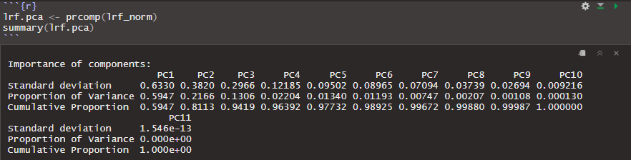

Figure 15: Proportion of variance distribution for individual principal components

|  |  |
| --- | --- |
| **Principal Components** | **Correlation Value** |
| First component | 0.29 |
| Second component | 0.16 |
| Third component | -0.08 |
| Fourth component | -0.09 |

*Table 2: Correlation Value of first four principal components with engagement*

For the topics variable, it had to be converted into three separate columns namely level 1, level 2, and level 3 where level 1 indicates the main topic of the course and remaining two levels indicate the sub topics. This was done by specifying the separator delimiter as comma. Few inconsistencies were found during the conversion of one column into three columns such as commas within a single topic that was manually corrected. There were 16384 missing values found in level 3 that were replaced by ‘missing topic’. Thereafter, two different scaling approaches were used on the data, first min-max scaler and second standardisation with mean value centred to zero. The dimension of new was 32190 rows and 144 columns in both cases. From the min-max scaler, around 42% proportion of variance was covered in the first two components whereas using the standardising the data with mean value centred to zero approach showed that only 13% of the data is stored in the first seven principal components.

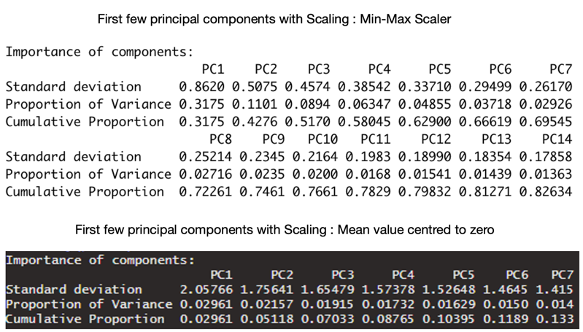

Figure 16: Proportion of Variance after one-hot encoding on topics using different scaling methods

For both the cases, there was no strong correlation obtained with the engagement variable. Therefore, it was found that when we consider type of the course, it covers more variance and for the topics we had to figure out the best scaling technique amongst all that would give us better results.

Week 11(Pallavi)-

Linear regression (Mali)

After many data exploration techniques and running PCA, the randomness of the data has been rejected so predicting the engagement variable as the target is going to be undertaken. As the target variable is numeric, Linear regression has been chosen as the machine learning prediction method.

Applying linear regression needs some data preparation. Firstly, the datasets learning_resources_features, completion_count and, enrolment_count has been mereged. Next, the target variable engagement has been created by dividing two variables total_compelition and total_enrol. Then NA values, extreme outliers and the ID columns have been removed. The column producer_reputation is converted from character to numeric. Normalizing the dataset is the next step. Now the data is ready to apply Linear Regression as the ML model. The results of performing the ML models shows as following:

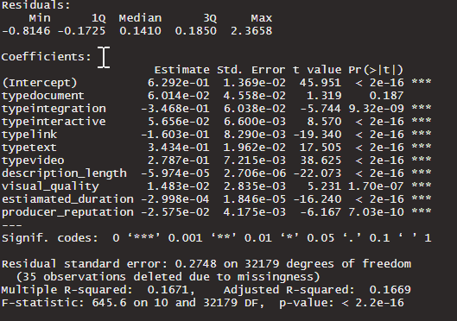

Figure 17: Linear Regression Model Performance Results

Looking at the residuals that are the difference between the predicted values and the actual observation, they should have a normal distribution with the mean value of zero while in this case the residuals do not appear to be symmetrical. Plotting the residuals would help to find out more about their distribution. As figure x demonstrates the values of residuals verses fitted values have not equally spread out around the horizontal line it indicates there might be a non-linear relationship. The Q-Q plot of residuals shows the standardised residuals are almost close to the stright lineas a result the residuals are almost normally distributed.

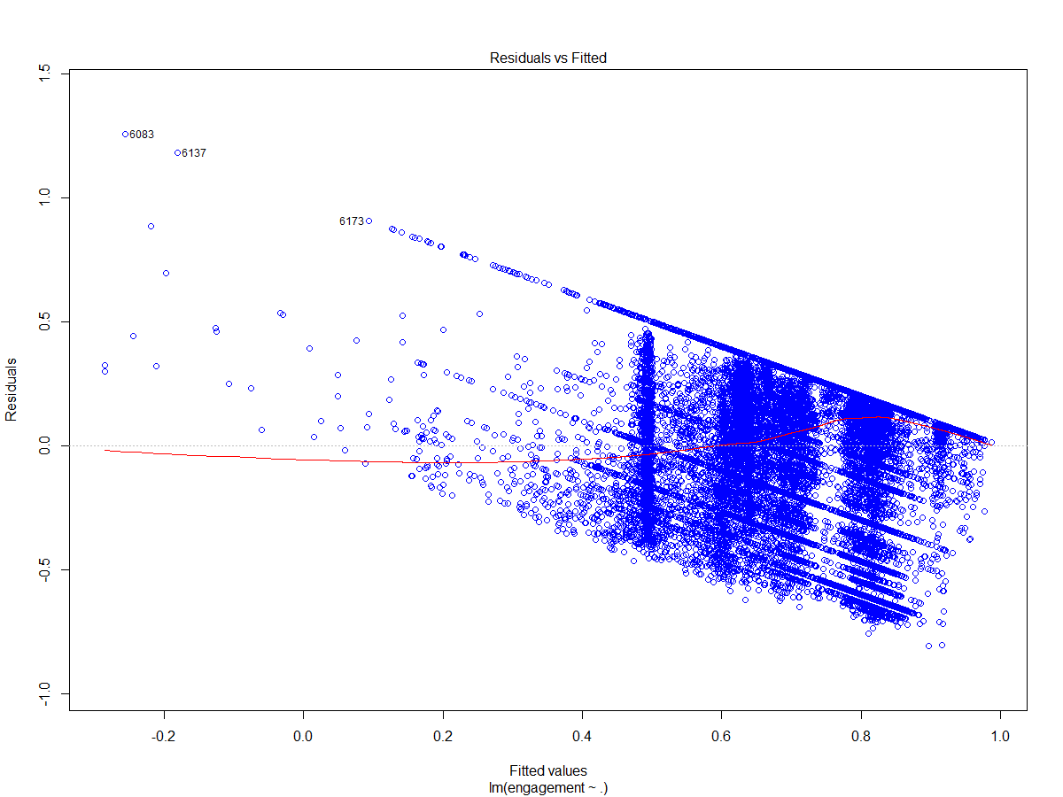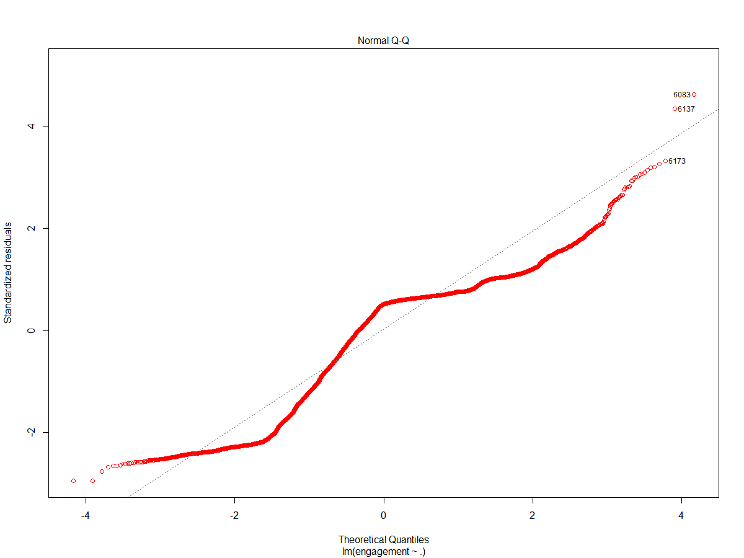

Figure 18: Residual vs Fitted and Normal Q-Q Plot for the Regression Model

The values of (pr>|t|) are very small in the summary of the model (figure x) and it means there are a relation between the features and the target variables and the values which have been predicted have not been created by chance. The R-squared is very small and closer to zero which indicates the regression dose explain the variance well in the response variable.

Another bonus task given to us was to find out the optimal estimated duration of the course.

The optimal value for the estimated duration was found out by using some plots and comparisons with some of the other features. The optimal duration of the learning object of the type video was the highest as compared to the other learning resource types. The estimated duration was plotted with learning resource features like description length, producer reputation and visual quality as shown below.

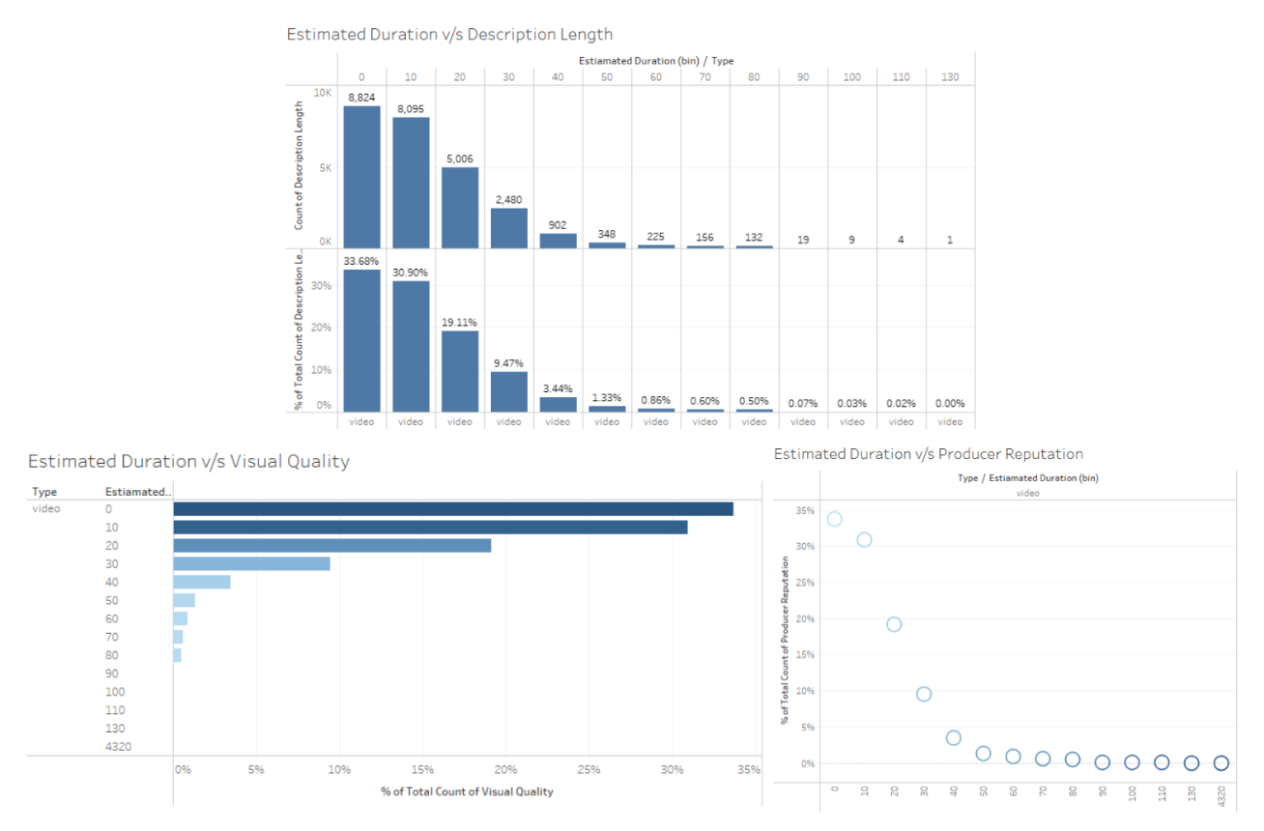

Figure 19: Estimated Duration with description length, visual quality & producer reputation

It can be observed that the optimal duration is between 0 to 30 as most of the records have a duration between these values.

NLP on title-

Moving on to the part where the to find a solution for the bonus i.e., to determine which words in the title column would bring out more customer engagement, this could be found by using natural language processing on the words in the title column. The pre-processing steps involved removing unnecessary punctuations, stop words, words with less than 3 characters and then perform tokenization. To find the unigrams, bigrams and trigrams using the term frequency, one single list was formed from all the words in tokenized title column. Using the nltk package, top 25 unigrams, bigrams, and trigrams were found. The most common words were as follows

1. Unigrams: photography, part, and business
2. Bigrams: (fast, start), (adobe, photoshop), & (class, introduction)
3. Trigrams: (comptia, security, sy0501), (mark, fast, start), & (fine, art, photography)

To explore words that bring more engagement, learning resource features and engagement (completion rate/enrolment rate) were merged and total 187287 words were found in title column with a vocabulary size of 11756. The engagement column was converted into categorical column with three categories namely High (0.7-1), Medium (0.4-0.7), and Low (0-0.4). Bag of words was created using the count vectorizer and logistic regression was performed that resulted in 63.2% accuracy, precision score of 0.67, and recall score of 0.63. Also, by using the t-Distributed Stochastic Neighbor Embedding (t-SNE) plot as shown in figure 32, it was found that words in title did not form individual clusters while exploring the relation between count vectors and engagement.

Week 12(Pallavi)

From the previous results it was observed that most of the values in the engagement variable were equal to 1 that was causing data imbalance and further resulting in poor performance of the machine learning model. Looking at the histogram in figure 20, the number most of the learning resources are of type video where most of the values for the variable engagement is equal to one.

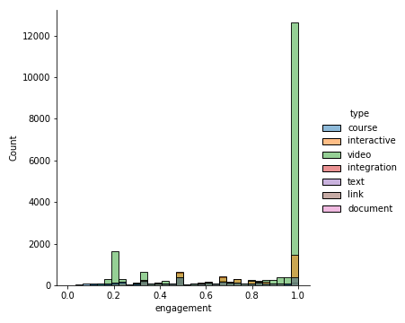

Figure 20: Engagement count with respect to type of the course

Therefore, we used two different approaches to model the data given below:

Approach 1: Using the original data (after performing the data pre-processing steps) to perform linear regression

Approach 2: under sampling the whole dataset, keeping only 2000 rows with engagement value equal to one and continuing with the other data as used in Approach 1. This way, the data set is not imbalanced anymore.

Then the relation between the engagement and distinct categories of type was explored using a box plot for both approaches. Comparing the boxplot of type by engagement (figure 21) shows the value of engagement for when the type of learning object is equal one has been balanced after under sampling.

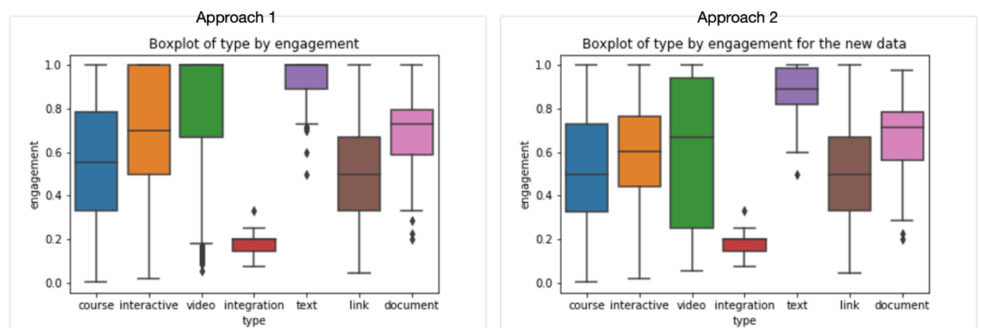

Figure 21: Boxplot for Approach 1 & Approach 2

Performing the linear regression for before and under sampling the dataset gives the following results (figure x):

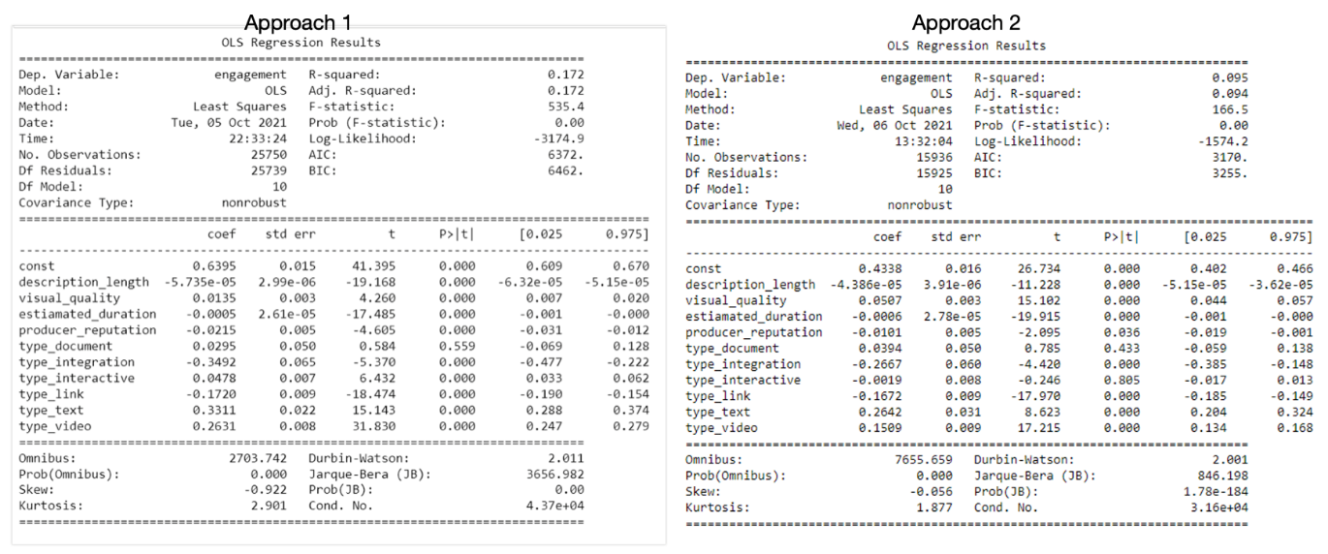

Figure 22: OLS classification report for Approach 1 & Approach 2

The modelling in Approach 1 results in a greater value of R-squared. Considering **R-squared** is the measurement of how much of the independent variable is explained by changes in our dependent variables. In percentage terms, 0.172 would mean our model explains 17.2% of the change in our ‘engagement’ variable while it is just equal to 0.095 for the second approach.

Comparing the predicted values for both approaches in figure x shows a better result for approach 2.

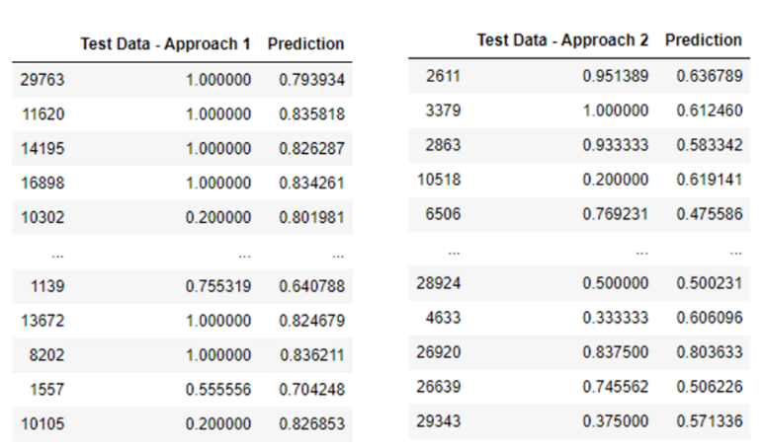

Figure 23: Predicted Value Comparison for Approach 1 & Approach 2

For NLP on title another approach, Term Frequency-Inverse Document Frequency (TF-IDF) vectorization was used. The corpus list for TF-IDF vectorization contained words with clean tokenized from title and label list contained all engagement categories. The t-SNE plot as shown in figure 32, revealed that no separate clusters were formed even after using TF-IDF vectors and the logistic regression model for the same returned 63.7% accuracy with 0.67 precision and 0.63 recall score.

Week 13(Pallavi)-

**Predicting the Engagement of the learning objects: -**

The learning resource features that were selected for predicting the engagement were type, description length, visual quality, estimated duration and producer reputation. As, the type column is categorical, one hot encoding was applied to it and was to converted to numeric. The following image is the screenshot of the data used for classification.

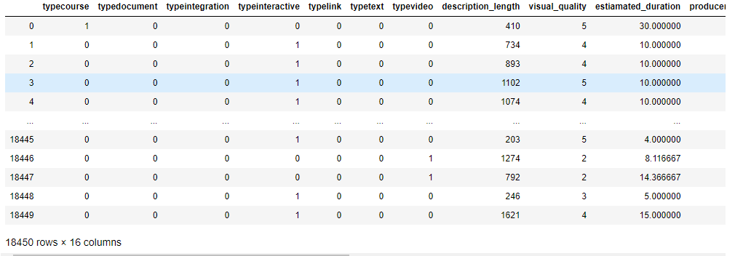

Figure 24: Final pre-processes data

The engagement variable was the target variable which was numeric. The engagement variable was converted to categorical. The categories were low (below 0.4), medium (0.4 to 0.7) and high (above 0.7). Now, as the target variable is categorical, the objective became a classification problem.

The data was pre-processed and prepared for the classification algorithms. The data was split into train and test datasets. 80% of the data was used for training the models and 20% of the data was used as test data. However, it was found however that the training data was imbalanced. Around 50% of the data had high engagement. We needed to balance the training data before classification. Undersampling technique was used to balance the data. Undersampling is used to balance an unbalanced dataset by removing some the entries which belong to the majority class. The imbalanced-learn library was used to perform undersampling on the data. The balanced data was then used for classification. The categories low, medium and high were assigned the labels 1, 2 and 3 for the purpose of classification.

The following classification algorithms were used to classify engagement.

1. K Nearest Neighbours (k = 3)

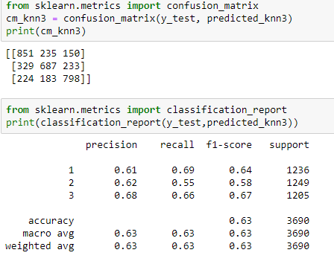

Figure 25: Performance Metric for K Nearest Neighbor with k=3

1. K Nearest Neighbours (k = 7)

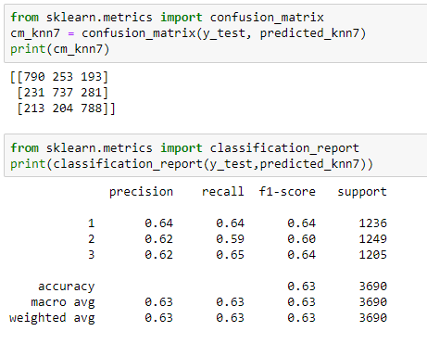

*Figure 26: Performance Metric for K Nearest Neighbor with k=7*

1. Decision Tree

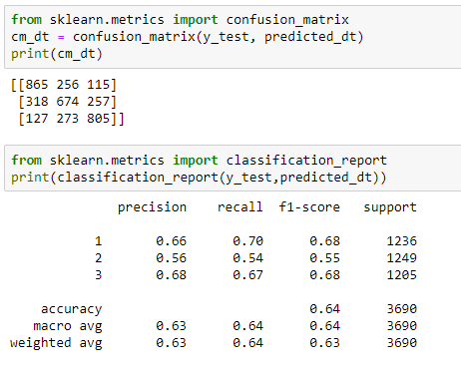

Figure 27: Performance Metric for Decision Tree Classifier

1. Logistic Regression

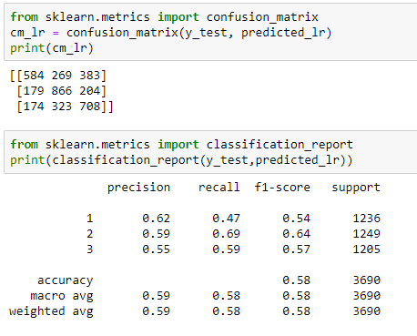

Figure 28: Performance Metric for Logistic Regression

1. Naïve Bayes

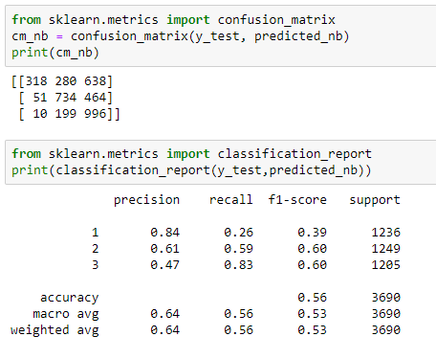

Figure 29: Performance Metric for Naïve Bayes

1. Random Forest

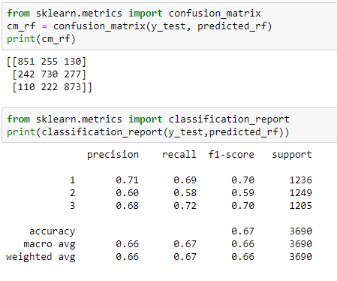

Figure 30: Performance Metric for Random Forest

1. SVM

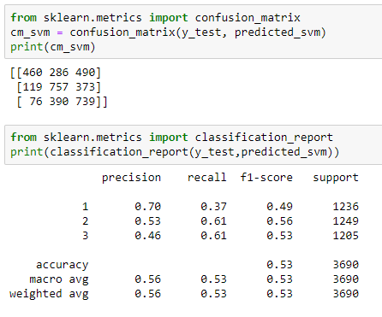

Figure 31: Performance Metric for Support Vector Machine

Overall, it can be stated that the model Random Forest provided the best F1 scores for all the three categories (low, medium, and high). The accuracy of classification is 66.5%. The Decision Tree and K Nearest Neighbours (k = 7) ranked close behind the Random Forest model in terms on the categories’ individual scores.

Moving towards the NLP on title, another approach to create vector embeddings using pre-trained FastText word embeddings was used. Total 32,228 rows with 2 columns (engagement & title) were found after performing tokenization and removing extra whitespaces as well as any unnecessary stop words or punctuations from the title variable. A corpus with all the tokenized titles was created and after loading the pre-trained fasttext model, a vocabulary was built using this corpus.

The FastText model was trained by specifying the corpus file, epochs, total examples, and total words. This further gave individual vector representation for each title from which total 5 rows with missing values were returned. When the t-SNE plot was considered, it looked like the model will perform good as compared to count vectors and tf-idf vectors as it was able to show slight separate clusters.

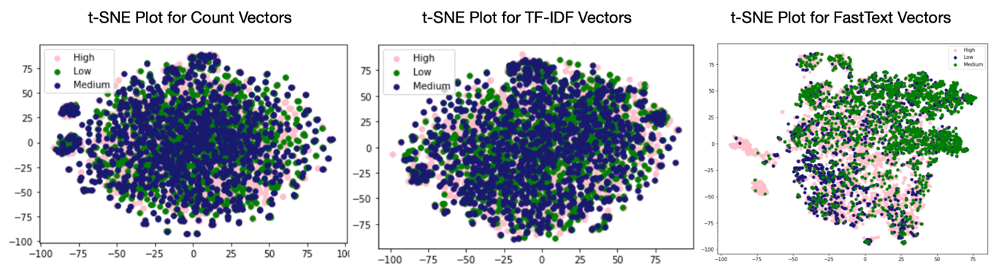

Figure 32: t-SNE Plot comparison for count vectors, TF-IDF vectors and FastText vectors

After removing the missing values and performing logistic regression, the model came out to be 62.93% accurate. But when other scores from the performance metrics were observed such as precision and recall, it was found that high engagement category had high precision and recall score of 0.92 and 0.77 respectively whereas, for medium and low categories it was extremely low that can be seen from the results given below:

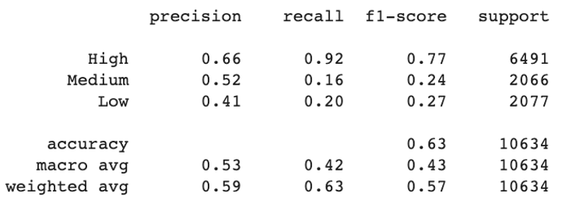

Figure 33: Perfomance Metric for Logistic Regression using FastText embedding

Therefore, due to the deficient performance of this model, we decided not to rely on it.

Coming back to the results obtained from the TF-IDF vectorization, it was then thought we could improve and enhance the performance of the model using this approach. To improvise, certain parameters were changed to get best outcomes. The following parameters were tuned while creating the tf-idf vectors:

* logarithmic form for frequency
* minimum numbers of documents a word must be present in to be kept is set as 5.
* ensuring all feature vectors have a Euclidian norm of 1
* considering both unigrams and bigrams
* removing stop words (common words such as ‘a’, ‘as’, ‘the’, etc.)

The feature shape of tf-idf vectors was 32338 rows with 8630 columns.

Subsequently, the most correlated unigrams and bigrams for high, medium, and low categories were found as show below:

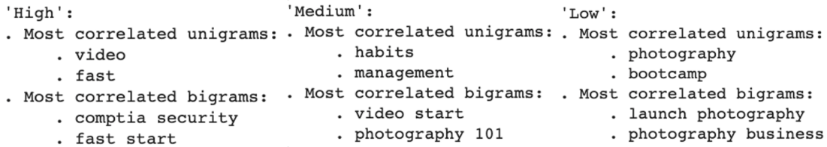

Figure 34:Top two Correlated Unigrams & Bigrams for each category of engagement

Furthermore, the evaluation and performances of different machine learning models such as Linear SVM, Logistic Regression, Multinomial Naïve Bayes and Random Forest classifier with k-fold cross validation was noted. The results were as follows:

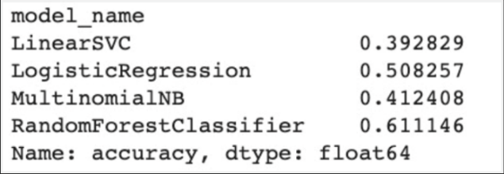

Figure 35: Accuracies for different models after k-fold cross validation

The logistic regression returned an accuracy of 73.80% without cross validation and average recall score of 0.60. We also decided to perform oversampling on the minority classes (medium and low engagement) and under sampling on majority class (high engagement) to check whether better results are attained. The oversampling on logistic regression model resulted in 67% accuracy and 0.65 average recall score. The results for over sampling are shown below:

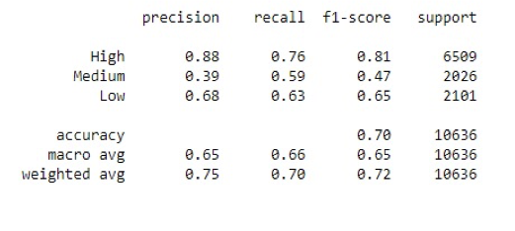

Figure 36: Performance Metric for Logistic Regression with oversampling

Whereas, considering the under-sampling results, same accuracy of 67% was observed with slightly better recall score of 0.67. The results for under sampling are shown below:

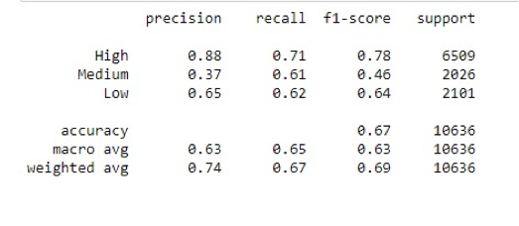

Figure 37: Performance Metric for Logistic Regression with under-sampling

The best models after tuning the parameters obtained were logistic regression model and support vector machine. After parameter tuning, although the accuracy of model decreases to 67% but the recall score increases to 0.67. The results for the same are shown below:

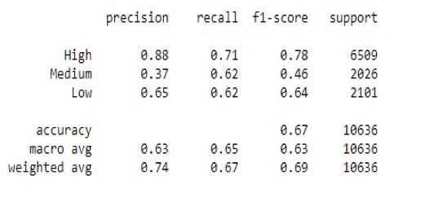

Figure 38: Performance Metric for Logistic Regression with parameter tuning

Support Vector Machine turned out to be the best machine learning model for the classification of engagement categories that gave highest accuracy of 69% with 0.67 best recall score. The results are given below:

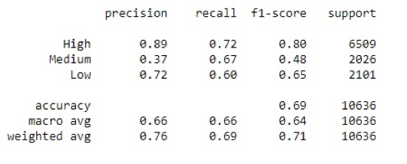

Figure 39: Performance Metric for Support Vector Machine

**Results & Evaluation**

1. **Correlation Analysis**

When individual correlation between clicks, consumption, and conversions with producer reputation after performing the t-test was observed, it was found that we had to reject the null hypothesis as the p-value was much smaller than 0.05. This showed that the true difference in means is not equal to 0, therefore these variables were independent of each other.

Moreover, after merging all the datasets together, it was noted that there is a slightly negative correlation between visual quality and producer reputation.

1. **Hypothesis Testing**

After performing hypothesis testing on different pairs of variables where the null-hypothesis was that the difference between the means is equal to zero and alternative-hypothesis stated that the difference between the means is not equal to zero, the following table shows t-test results for different pairs of variables along with its observed p-value and whether these are correlated or not:

|  |  |  |  |
| --- | --- | --- | --- |
| **Variable Pairs** | **P-value** | **Results** | **Correlation** |
| Visual Quality and Producer Reputation | Less than 0.05 | Statistically significant results | Independent of each other |
| Completion Count and Enrolment Count | Less than 0.05 | Statistically significant results | Independent of each other |
| Type and Engagement | Less than 0.05 | Statistically significant results | Independent of each other |
| Estimated Duration and Engagement | Less than 0.05 | Statistically significant results | Independent of each other |

Table 3: Hypothesis Testing Results for different variable pairs

1. **Principal Component Analysis**

When all the numeric variables are considered, most of the proportion of variance (approx. 95%) was being covered in the first two components. A positive correlation of first principal component with engagement with value of 0.25 was obtained whereas other three components showed slightly negative correlation with the target variable.

Similarly, when the character columns (topics and type) are considered, it was found that type of the course covers most of the variance (96.39%) in first four principal component whereas topics could not cover most of the variance in its first few principal components. This revealed that type and all numeric columns could be considered for building a machine learning model, this also proved that the data is useful.

1. **Classification Model Comparison**

|  |  |  |  |  |
| --- | --- | --- | --- | --- |
| **Model** | **Accuracy** | **Precision** | **Recall** | **F1 Score** |
| KNN (k = 3) | 63.30% | 0.63 | 0.63 | 0.63 |
| KNN (k = 7) | 62.73% | 0.63 | 0.63 | 0.63 |
| Decision Tree | 63.52% | 0.63 | 0.64 | 0.63 |
| Logistic Regression | 58.48% | 0.59 | 0.58 | 0.58 |
| Naive Bayes | 55.50% | 0.64 | 0.56 | 0.53 |
| Random Forest | 66.50% | 0.66 | 0.67 | 0.66 |
| SVM | 53.01% | 0.56 | 0.53 | 0.53 |

Table 4: Model Comparison table for classification based on accuracy, precision, recall & f1-score

It was advantageous to create a pipeline of the classification models and compare the results. The above model comparison table shows the accuracy, precision, recall and F1 scores for different machine learning models including KNN, Decision Tree, Random Forest, SVM, Naïve Bayes and Logistic Regression.

After the performance metrics for different models was compared, it could be inferred that the classification for the engagement by using the balanced one hot encoded data yields the best results by using Random Forest with a prediction accuracy of 66.5%.

1. **Model Comparison for NLP on Title**

After trying several combinations and using different vectorization methods such as creating count vectors, tf-idf vectors, fastest embedding and performing logistic regression, SVM, using these approaches, the following results in the table given below were obtained:

|  |  |  |  |  |
| --- | --- | --- | --- | --- |
| **Model** | **Accuracy** | **Precision** | **Recall** | **F1 Score** |
| Logistic Regression (count vectors) | 63.2% | 0.67 | 0.63 | 0.64 |
| Logistic Regression (TF-IDF vectors) with tuned parameters | 67% | 0.63 | 0.65 | 0.63 |
| Logistic Regression (TF-IDF vectors) Over Sampling | 70% | 0.65 | 0.66 | 0.65 |
| Logistic Regression (TF-IDF vectors) Under Sampling | 67% | 0.63 | 0.65 | 0.63 |
| Logistic Regression with pre-trained FastText Model | 63% | 0.53 | 0.42 | 0.43 |
| Support Vector Machine (TF-IDF vectors) | 67% | 0.66 | 0.67 | 0.64 |

Table 5: Model Comparison Table for NLP on Title based on accuracy, recall, precision & f1-score

From the above table it was evident that SVM performed the best on tf-idf vectors of words in the title corpus that returned best recall score of 0.67 with 67% accuracy.

**Conclusion**

From the results obtained after finding Pearson’s correlation coefficient value and performing hypothesis testing using Welsch two sample t-tests, statistically significant results were found with corresponding p-value<0.05 in every case i.e., visual quality and producer reputation, Completion Count and Enrolment Count, Type and Engagement and lastly, Estimated Duration and Engagement. All these variable pairs were found to be independent of one another and there was no significant correlation found between them.

After performing PCA to check whether the data is useful or not, producer reputation, description length, estimated duration, visual quality and type were successful in covering most of the variance and hence, the features that help in predicting the quality of learning resources and user engagement were found.

Various machine learning models and their respective performance metrics revealed that Random Forest was the best classification model to predict the engagement categories with 66.5% accuracy and 0.67 recall score. For the natural language processing, the best machine learning model was found to be Support Vector Machine that was trained with TF-IDF vectors from the corpus and vocabulary of title column. It attained 67% accuracy along with 0.67 recall score. Apart from the main results, the results obtained from the bonus tasks were that optimal duration for a learning resource if between 0 to 40 and top correlated unigrams for high, medium, and low engagement were video, habits and photography respectively.

* What are possible future directions for this project? What was left undone?

**Appendix**

**Roles & Responsibilities:**

* Who are the team members?
* Clearly and exhaustively detail everyone’s roles and responsibilities.
* Provide details on how you collaborated virtually with everyone on the team. What tools did you use? How often did you meet? How much time did you spend working “together” in a virtual environment? How much time did you spend working alone?

**Self-Reflection:**

Self-Reflection (Anurag Karmarkar)

Self-Reflection (Malileh Habibi)

Self-Reflection (Pallavi Bhimte)

**References**

[1] <https://elearningindustry.com/directory/elearning-software/go1>

[2] <https://www.elucidat.com/blog/online-learning-vs-face-to-face-learning/>

[3] <https://comparecamp.com/go1-reviews-pricing-pros-cons-features/>